EnergyScout: A Consumer Oriented Dashboard for Smart Meter Data Analytics

1. **Introduction**:

Smart meters; dynamic pricing for peak & off- peak hours which is collected & analyzed by smart meters & lets spread utilization to reduce bills

* EnergyScout
* As of 2016, 63 million smart meters have been installed, covering about 52% of all US households [2].
* However, recent reports have shown that only a small fraction of household customers (6%) have opted for dynamic pricing citing lack of access to smart data

1. Background & relevant info
2. Design goals guiding development
3. System & implementation
4. Results & discussion

Prototype features:

* Focus on single-stream data as provided by the currently dominant source of household energy data - smart meters.
* Enable users to **draw comparisons with historical data**
* Introduce a high degree of interaction and fluidity into the inter-face to entice users to playfully explore the data
* Enable **explanations for energy consumption** by providing and linking contextual information, such as weather and calendar
* Design an expressive **what-if analysis** tool that fits the need of an enthusiast but also invites the average consumer to try
* Expand the system’s use to an **educational tool** that nudges people into thinking **about energy usage and improving awareness**

**5.1. Time-Series Exploration:**

* The most popular and straightforward representation of a time series is the line plot, with time mapped to the x-axis and value mapped to the y-axis

**5.1.1. Our multi-level time series exploration interface:**

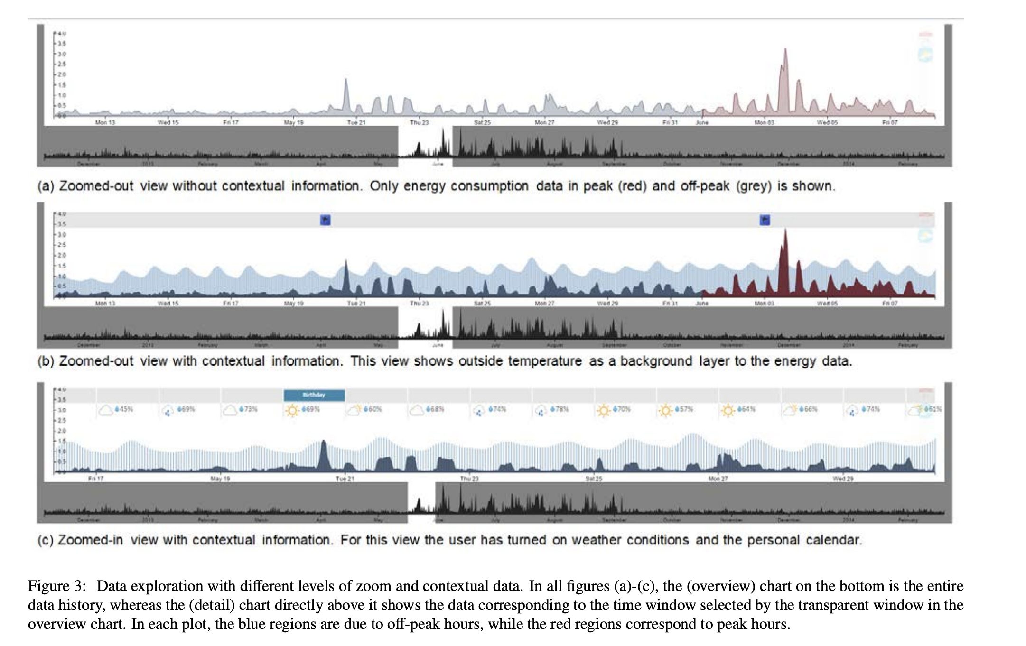

**5.2.1. The Weather Context Display**

- temperature, humidity, and weather condition (sunny, cloudy, etc.)

**5.2.2. The calendar context display**

1. conclusion